Images of our June 2021 visit to The Hedges on Blue Mtn. Lake, NY

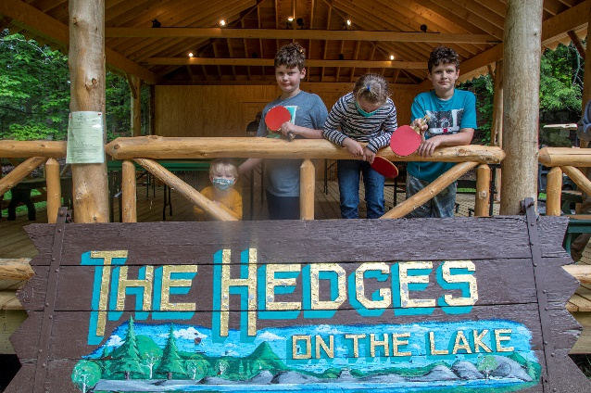 Our annual visits to the Hedges began in the summer of 1994. This year Dave and Steve and their families joined joined us during some excellent weather and water time with kayak and canoeing, paddleboarding, swimming, and fishing. The Dining room meals were excellent as was the daily housekeeping and the new head cook lived up to her excellent reputation. We did manage a photo or two for our memories. Grandson Greyson joined the family ranks of Bald Rock conquers and everybody who fished caught fish! Jim and Phinie kayaked into Utawana Lake as usual and enjoyed wonderful moments with everyone.   
   
We have created separate albums for photos of Greyson as he conquers Bald Rock- 2X - click on [Grey Conquers the Rock June 13, 2021](https://photos.app.goo.gl/56CEuWGi9YbqAHYG6); the ospreys constructing their new [island nest](https://photos.app.goo.gl/xpZsVecVFaJX3ADu7); the long-awaited opening for the [Blue Mtn. Diner](https://photos.app.goo.gl/Re74Qxy6CTvnhhADA), and sounds from our cabin of an evening [thunderstorm on the lake](C://Users/James%20H.%20Faux/Documents/coffee%20cup/fauxes.net/Sounds/Condo%20Sounds/Hedges-3-June%2014%202021%2024542%20AM.mp3).

And for the photos of our family photos at the Hedges, click [The Hedges: June 2021](https://photos.app.goo.gl/vcZ618gjH3THmuNV7).

Until next Year!